PROJECT REPORT

IRevolution: A Data Driven Exploration Of Apple’s IPhone Impact In India

- INTRODUCTION

  - Overview

In this project,we have analyse the market penetration of iPhone in India.Based on the Sales on the different products introduced by Apple in India.

1.2 Purpose

The purpose of this project is to create awareness about the feasibility of improving the sales of Apple iPhone in India.

- PROBLEM DEFINITION AND DESIGN THINKING
2.1 Empathy map
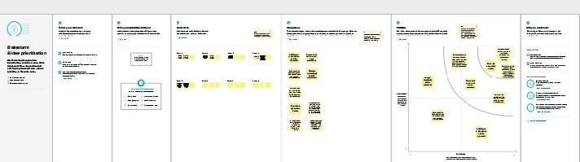

2.2 Brainstorming Screenshot

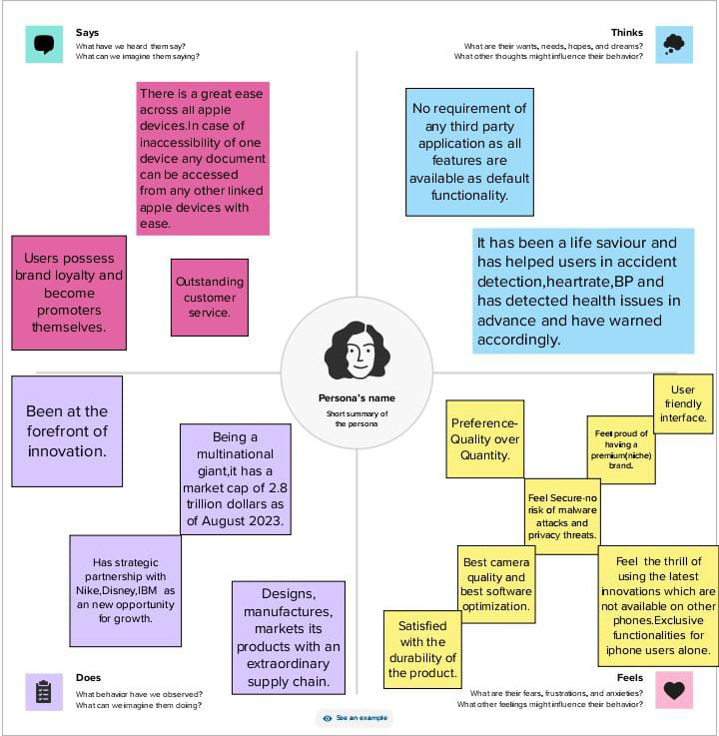

3 RESULT
From our exploration we come to know that iPhone products has a very big impact on this society for the past 10 years.

4 ADVANTAGES AND DISADVANTAGE
Advantages:
- Better performance.
- Have tighter Security.
- Unlikely to be infected with a virus.
Disadvantage:
- Limited customization.
- Highly priced product.
- Incompatibility with other software.
5 APPLICATIONS
Apple consider any iPhone with a battery capacity above to be in optimal condition and inbuilt privacy features. iPhone products has a very good control accessories from our home.
6 CONCLUSION
•There are many other benefits of using an iPhone. It is no wonder, people who are accustomed to using the iPhone have a very difficult time when they have to choose a different phone other than the iPhone. Its speed, design and classy look make it a trailblazer in its way.

7 FUTURE SCOPE
- With so many benefits of iPhone over Android, it can be easily understood why iPhone are preferred more over Android device when it comes to recommending someone which phone to buy. iPhone provides much better technical support and also you can update the latest IOS much more easily than in Android phones. Also, iPhone is preferred more than Android device when launching a new mobile app.

